**ASSIGNMENT 4: RISHABH GAUR**

**Q1.** Create a list, a tuple and a set. Traverse each element of these sequences.

**OUTPUT:-**

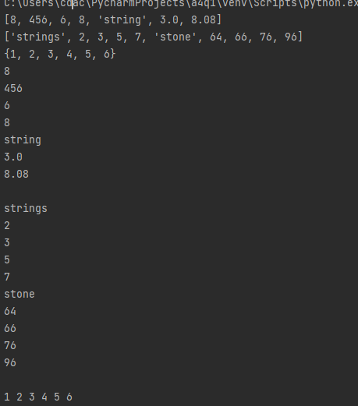

**Q2.** Create 2 set objects by taking input from the user. Perform the following functions:-

1. Len
2. Min
3. Max
4. Sum
5. Union
6. Difference
7. Intersection
8. Symmetric_difference
9. Issuperset
10. Issubset

**OUTPUT:-**

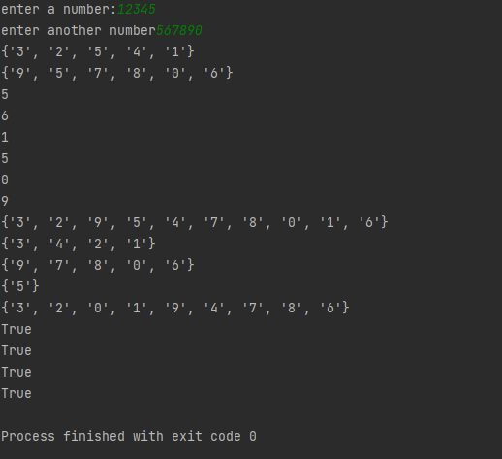

**Q3.** Input 5 numbers from user and store them as immutable sequence. Find:-

1. Min
2. Max
3. Sum
4. Sort the sequence

**OUTPUT:-**

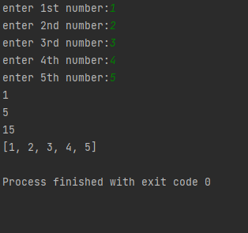



**Q4.** Write a program to demonstrate tuple operations:-

1. Tuple concatenation
2. Tuple repitition

**OUTPUT:-** 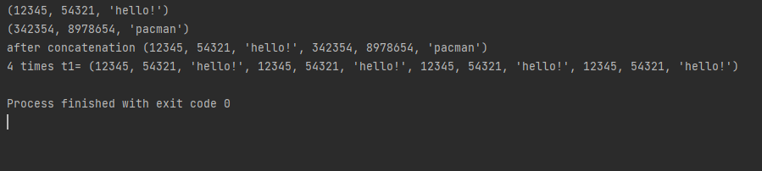

**Q5.** X = [(10,20,30),(40,50,60),(70,80,90]

Required output:-

Enter a no.= n

List becomes [(10,20,100),(40,50,100),(70,80,100)]

**OUTPUT:-**

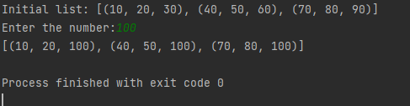

**Q6.** Y = ((10,10,10,12),(30,45,56,45),(81,80,92,56),(1,2,3,4)

Required output:-

Minimum value of numbers:

Maximum value of numbers:

Average of numbers:

**OUTPUT:-**

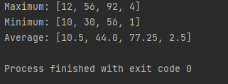

**Q7.** Fruits = ((‘mango’,’grapes’,’dragonfruit’,’watermelon’,’kiwi’,’pomegranate’,’dates’,’papaya’),

(‘apple’,’banana’,’orange’,’litchi’))

Required output:-

Enter fruits:- fruit

Available/not available

**OUTPUT:-**

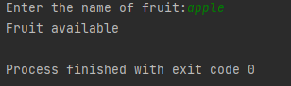

**Q8.** a =(1,2,3,4) b =(3,5,2,1) c =(2,2,3,1)

Required output:- (6,9,8,6)

**OUTPUT:-**

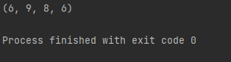

**Q9.** X = [(1,2),(2,3,5),(3,4),(2,3,4,2)]

Required output:- [[1,2],[2,3,5],[3,4],[2,3,4,2]]

**OUTPUT:-**

